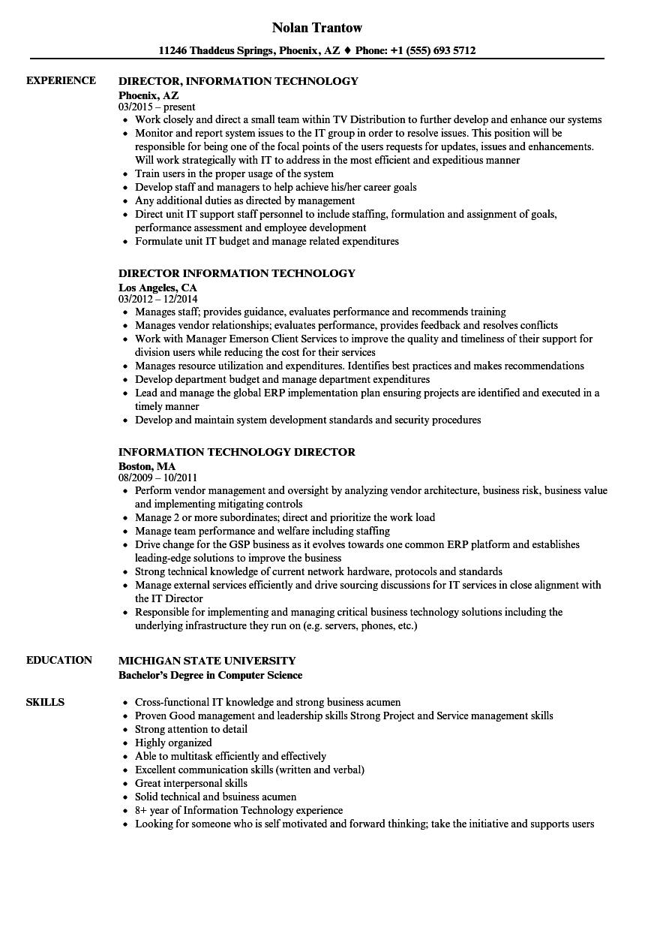
EXPERIENCE
Nolan Trantow
11246 Thaddeus Springs, Phoenix, AZ ♦ Phone: +1 (555) 693 5712
DIRECTOR, INFORMATION TECHNOLOGY
Phoenix, AZ
03/2015-present
• Work closely and direct a small team within TV Distribution to further develop and enhance our systems
• Monitor and report system issues to the IT group in order to resolve issues. This position will be responsible for being one of the focal points of the users requests for updates, issues and enhancements. Will work strategically with IT to address in the most efficient and expeditious manner
⚫ Train users in the proper usage of the system
• Develop staff and managers to help achieve his/her career goals
• Any additional duties as directed by management
⚫ Direct unit IT support staff personnel to include staffing, formulation and assignment of goals, performance assessment and employee development
• Formulate unit IT budget and manage related expenditures
DIRECTOR INFORMATION TECHNOLOGY
Los Angeles, CA
03/2012 - 12/2014
⚫ Manages staff; provides guidance, evaluates performance and recommends training
• Manages vendor relationships; evaluates performance, provides feedback and resolves conflicts
• Work with Manager Emerson Client Services to improve the quality and timeliness of their support for division users while reducing the cost for their services
• Manages resource utilization and expenditures. Identifies best practices and makes recommendations
• Develop department budget and manage department expenditures
• Lead and manage the global ERP implementation plan ensuring projects are identified and executed in a timely manner
• Develop and maintain system development standards and security procedures
INFORMATION TECHNOLOGY DIRECTOR
Boston, MA
08/2009 - 10/2011
• Perform vendor management and oversight by analyzing vendor architecture, business risk, business value and implementing mitigating controls
• Manage 2 or more subordinates; direct and prioritize the work load
• Manage team performance and welfare including staffing
⚫ Drive change for the GSP business as it evolves towards one common ERP platform and establishes leading-edge solutions to improve the business
• Strong technical knowledge of current network hardware, protocols and standards
• Manage external services efficiently and drive sourcing discussions for IT services in close alignment with the IT Director
• Responsible for implementing and managing critical business technology solutions including the
underlying infrastructure they run on (e.g. servers, phones, etc.)
EDUCATION
SKILLS
MICHIGAN STATE UNIVERSITY
Bachelor's Degree in Computer Science
Cross-functional IT knowledge and strong business acumen
• Proven Good management and leadership skills Strong Project and Service management skills
• Strong attention to detail
• Highly organized
• Able to multitask efficiently and effectively
• Excellent communication skills (written and verbal)
• Great interpersonal skills
• Solid technical and bsuiness acumen
⚫ 8+ year of Information Technology experience
⚫ Looking for someone who is self motivated and forward thinking; take the initiative and supports users

